NSCI 20100 Neuroscience Laboratory

Contrast Increment Thresholds

BSLC 322, January 3/5, 2018

**Goals:**

**Reading:** There is no required reading for this lab.

**Safety:** There are no lab safety issues related to this study. You will be working only with a desktop computer and its visual display. No PPE (personal protective equipment) is required or recommended.

**Data:** You should collect high-quality psychophysical data using five increments and two base contrasts. Working in pairs, each student should serve as a subject for two of the base contrasts.

**Lab Report:** Lab reports should be prepared following the general instructions found on the course [Canvas site](https://canvas.uchicago.edu/courses/11181/assignments/syllabus). Your report should include some consideration of the following:

*Introduction:* What is the Weber-Fechner law and how do contrast increments relate to it?

*Methods:* The task design you will use is a two-alternative spatial forced-choice design. Although a Yes-No design (in which a single stimulus either does or does not increment its contrast) could have been used, but is generally considered a less reliable way to measure thresholds. How many stimulus repeats are required to get reliable data?

*Results:* Include a figure showing your data in your lab report. Are your data generally consistent between subjects/base contrasts? Are there outlier points? If so, do you know why? What do your data say about the Weber-Fechner law?

*Discussion:* Discuss limitations of your data. For example, how many samples would it take to get a single base contrast/increment value with a 95% confidence interval of 1%? your data reveal anything conclusive about the way that sensory neurons use the dynamic range of their rate of firing to contrast?

**Laboratory Procedures**

You will be using a Matlab application to collect your data. The necessary software is installed and configured on each of the lab’s computers.

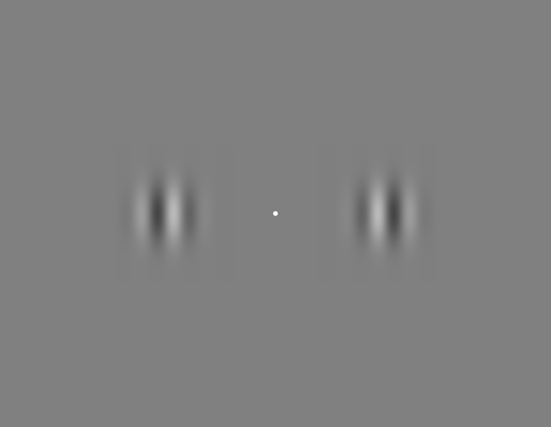

**Doing the Contrast Increment Task**

The stimulus display will appear as a dark gray window on the right half of the monitor. You can start and stop the task running using the control panel. Once started task will continue presenting successive trials until you stop it or the requested number of **Stimulus Repeats** has been completed for the current **Base Contrast**.

At the start of each trial, a dim white fixation spot will appear. You should hold your gaze on the fixation spot throughout each trial, looking away only between trials.

Once you (the subject) have fixated the spot and are ready to start a trial, you signal that you are ready by pressing the down arrow on the keyboard (while maintaining fixation). This will cause the fixation spot to turn bright white and for the two grating stimuli to appear. After the stimuli have been on the screen for the **Base Stimulus Duration** (1 s), one of the two stimuli, selected at random, will increase its contrast. The change will last for only the **Test Stimulus Duration** (0.25 s), after which both grating pattern will disappear and the fixation point will turn black. You must indicate which of the two gratings increased contrast by pressing either the left or right arrow on the keyboard. Once you respond, the task will pause for the **Inter-trial Duration**, after which the next trial will start.

Breaks: You can take a break at any time by pausing the task. It is also fine to leave the task waiting with the dim fixation spot on the screen. There is no reason not to stop part way through completing one base contrast to take a break while your partner works on another base contrast. It is generally best to collect data entirely from one person for each base contrast.

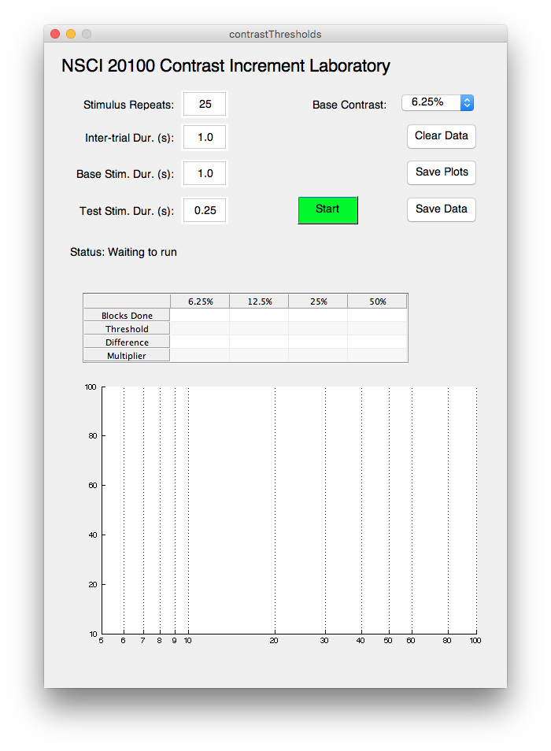

**Controlling the Task Increment Task**

**Stimulus Repeats:** The number of times each increment will be repeated before the task stops. If you reach the limit, you can always increase this number and collect more data.

**Inter-trial Dur. (s):** The pause between on trial and the start of the next. You may adjust this, but you should leave enough of a pause so the subject is not rushed.

**Base Stim. Dur. (s):** The duration of the adapting stimulus. Leave this set to 1.0 for all measurements.

**Test Stim. Dur. (s):** The duration of the test stimulus. Leave this set to 0.25 for all measurements.

**Base Contrast:** Use this menu to select which of the four base contrasts you will test.

**Clear Data:** Delete the data for the current base contrast (only).

**Save Plots:** Save the current contents of the plot as a PDF.

**Save Data:** Save the current data set as a Matlab mat file.

**Start (Stop):** Toggle whether the task is running. You can also use the space bar when the control window is front-most.

**Results Table:** The first row in column of data for each base contrast shows the number of blocks (of five increments) completed. Once a few blocks have been, the table will also display the threshold contrast, the difference between the threshold contrast and the base contrast, and the ratio of the threshold contrast and the base contrast.

**Performance Plot:** The performance plot shows the percent correct for each increment. Increments on different base contrasts are plotted in different colors. Colored solid vertical lines mark the four different base contrasts.